NORTHWOOD MUSIC ACADEMY PRICE LIST
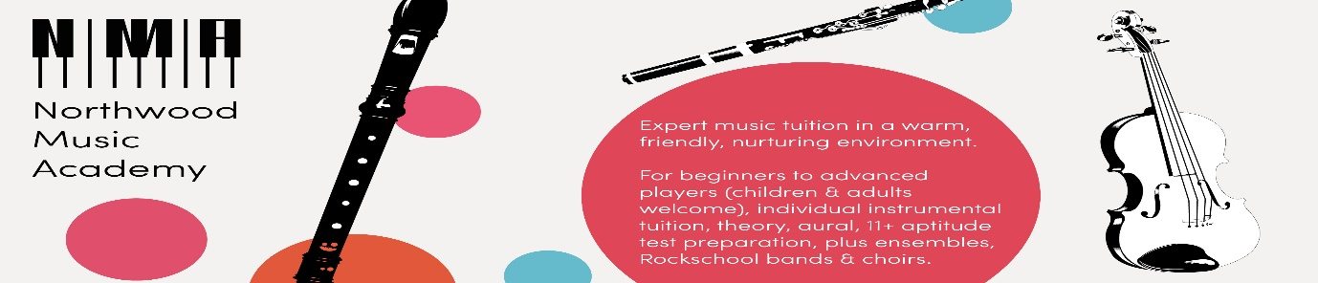
“We love music, and love to teach!”

Approximately 33 lessons are offered over the 3-term year. The number of lessons in each term will vary.
Please refer to the Terms and Conditions for more details.
1st TERM INTRODUCTORY OFFER - if you begin after a half term, then the INTRODUCTORY OFFER WILL CONTINUE UNTIL THE FOLLOWING HALF TERM
Type of lesson | Length | Payable by term: example block of 10
Individual lesson | 30 mins  1 hour | £205 (usually £230)  £410 (usually £460)
Choir  Wind band (min grade 1)  Brass ensemble (min grade 1)  Violin band (mixed beginner levels)  Junior Orchestra (grades 1 – 5) | 30 minutes | £69 (usually £75)
Chamber music | 1 hour | £72 (usually £80)
Rock band | 45 mins | £72 (usually £80)
Jazz or classical composition/improvisation group (individual lessons as ‘individual lesson’) | 45 mins | £72 (usually £80)
Theory and aural (grouped by ability – up to four students per class) | 45 minutes | £72 (usually £80)
Group beginner violin lessons for younger children | 45 minutes | £69 (usually £75)
General Musicianship group class  (age appropriate groups from KS1) | 30 minutes (KS1)  45 minutes (KS2+) | £59 (usually £65)  £72 (usually £80)

Contact: info@northwoodmusicacademy.com
Prices subject to modest review January 2019

